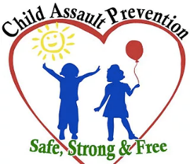
Child Assault Prevention (CAP) Project
122 Ridge Street, Suite B, Reno, NV 89501
775-348-0600 www.childassaultprevention.org

“Children are one third of our population and all of our future.”
--Select Panel for the Promotion of Child Health, 1981

Dear Friend of Child Assault Prevention,

As an advocate for children, we hope you understand the need for the Child Assault Prevention (CAP) Project and we want to invite you to become a part of promoting safe, strong, and free youth in our community! For 40 years, CAP has empowered generations of children to recognize and report abusive situations with bullies, strangers, internet predators, social media issues, as well as unsafe and secret touches from people they know and trust. The CAP program provides students with the foundational skills needed to ensure their safety into adulthood.

Here at CAP, we are always open and grateful for any donations that we receive to support the funding of our program. Currently, CAP teaches child safety to over 10,000 elementary age students in Washoe, Storey, Churchill, and Lyon counties on a very lean budget. Because 1 in 4 girls and 1 and 6 boys are sexually molested before the age of 18, and with the growing threat of physical, emotional and cyber bullying, today’s children are facing long-term threats to their well-being.

Please consider helping CAP reach as many students as possible. Your tax deductible contribution will help our children stay “SAFE, STRONG AND FREE”.

A donation link is on our website at www.childassaultprevention.org and there is more information on how to make your contribution online. If you would like to send your donation through mail instead, here is our address: 122 Ridge Street, Suite B, Reno, NV 89501.

Thank you for being a friend of CAP and a champion for the children of our community!

Sincerely,

Executive Director: Rebecca LeBeau
CAP Board of Directors: Roger Bahten, Betty Barker, Kristi Sprinkle, Tiffanie Story

