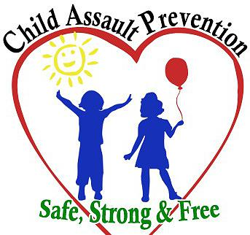

**Child Assault Prevention (CAP) Project of Washoe County**

122 Ridge Street, Suite B. Reno, NV 89501

(775) 348-0600 email: [admin@childassaultprevention.org](mailto:admin@childassaultprevention.org)

[www.childassaultprevention.org](http://www.childassaultprevention.org)

**PARTICIPANT GRIEVANCE POLICY AND PROCEDURE**

The Child Assault Prevention Project of Washoe County strives to provide excellent customer services to all clients and participants at all times. Grievance procedures have been developed to assist clients and participants in resolving problems. Clients and participants will not be subject to intimidation or other negative treatment for initiating a grievance process.

The Participant Grievance Procedure documents your complaints and the efforts of the Child Assault Prevention Project of Washoe County to resolve those complaints in order to ensure that services are maintained at competent levels of quality.

1) Participants should attempt to resolve all grievances informally with the staff member(s) involved. A formal review process should be used only when a satisfactory resolution has not been received through informal methods.

2) If the grievance cannot be resolved through discussion with the staff member(s), the participant should speak with the Executive Director, or summit a Complaint/Feedback form to: (Forms available at www.childassaultprevention.org)

Child Assault Prevention Project of Washoe County

Attn: Rebecca LeBeau, Executive Director

122 Ridge Street, Suite B

Reno, NV 89501

3) The Executive Director will write a Plan of Action to resolve the issue or incident. The Plan of Action will be sent to the participant within 30 days of receiving the written grievance. If the client does not respond within 30 days of receiving the Action Plan, the Child Assault Prevention Project of Washoe County will consider the incident or issue resolved.

4) If the participant is not satisfied with the Plan of Action, they may request in writing for a meeting or phone call with the agency Executive Director. The participant needs to provide an explanation about why the Plan of Action is not satisfactory. If the participant does not find an acceptable solution to the problem, the client may look for further assistance outside of the agency.

(December 16, 2021)

CHILD ASSAULT PREVENTION PROJECT OF WASHOE COUNTY

**PARTICIPANT GRIEVANCE FORM**

1. Please use this form to tell us about your experience or complaint

2. Please write clearly and use dark ink.

3. Complete the entire form and please sign at the bottom.

4. Please include copies of any documents that are important to your complaint.

|  |
| --- |
| Your Information |
| Name: Phone Number: |
| Email: |
| Address |
| Date of Incident: |
| Name of staff member(s) Involved: |
| Did you speak with staff member(s) involved to resolve the incident? |
| Briefly describe your experience: (use reverse side or additional sheets if necessary) |
|  |
|  |
|  |
|  |
|  |
|  |

**PLEASE READ THE FOLLOWING BEFORE SIGNING BELOW**

In signing this document, I have no objection to the contents being discussed with the person(s) the comments are directed toward. The above experience is true and accurate to the best of my knowledge. I also understand that any false statements will invalidate any complaint.

Signature: _____________________________________ Date______________________

**Return to: Child Assault Prevention Project of Washoe County**

**Attn: Rebecca LeBeau, Executive Director**

**122 Ridge Street, Suite B**

**Reno, NV 89509**

**Email:** [**admin@childassaultprevention.org**](mailto:admin@childassaultprevention.org) **Phone: 775-348-0600**

|  |
| --- |
| **OFFICE USE ONLY: Date Received: Follow-up Date:** |